**Lesson 01 Demo 02**

**Configuring Prometheus to Scrape and Visualize the Metrics**

**Objective:** To configure Prometheus to scrape and visualize metrics for monitoring system performance through its web interface for improved observability and real-time insights

**Tools required:** Linux operating system

**Prerequisites:** Basic understanding of Web Applications

Steps to be followed:

1. Start Prometheus binary
2. Explore Prometheus UI

**Step 1: Start Prometheus binary**

* 1. Run the following commands to change the current directory to the Prometheus directory and start the Prometheus server:

**cd prometheus**

**sudo ./prometheus --config.file=prometheus.yml**

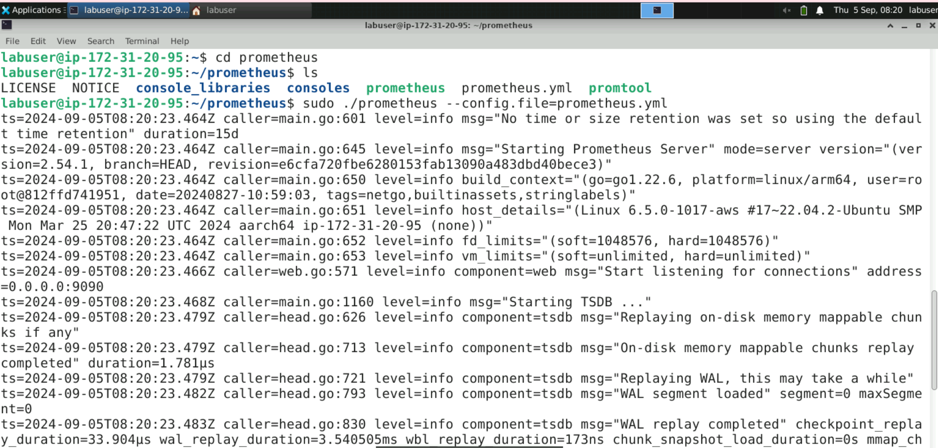

**Step 2: Explore Prometheus UI**

* 1. Navigate to the browser and enter the URL **http://localhost:9090/** or **http://<public-ip>:9090/** to access the Prometheus console

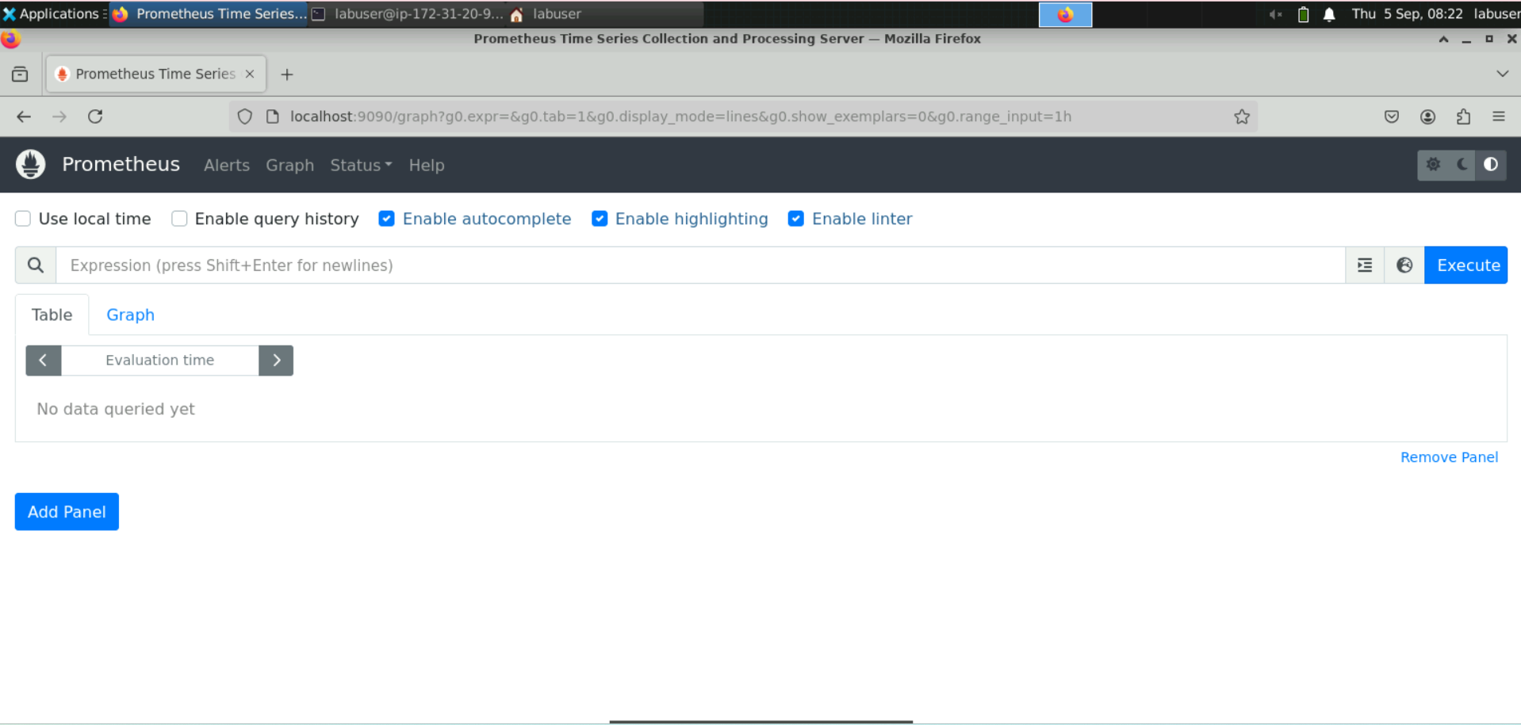

**Note:** The Prometheus server must run in the terminal to access the Prometheus UI.

* 1. Navigate to the **Expression Browser**, type **process_vi**, and then selectthe **process_virtual_memory_bytes** metric as shown

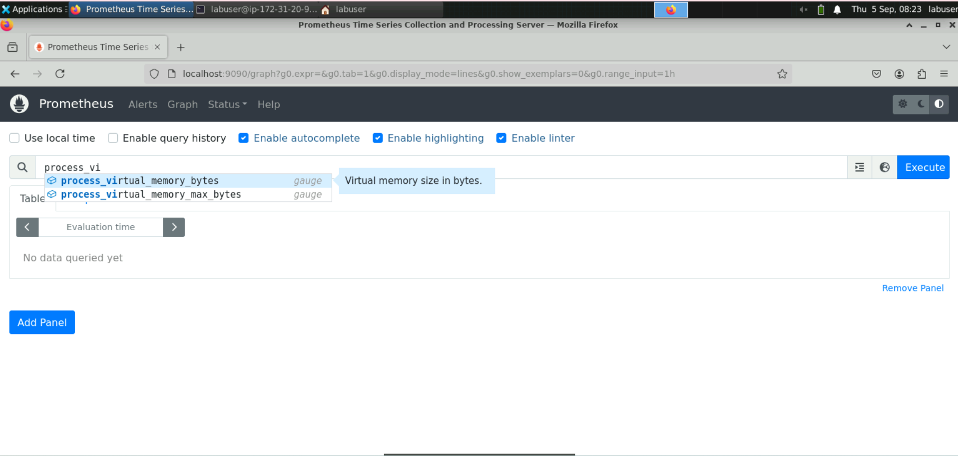

* 1. Click on **Execute**

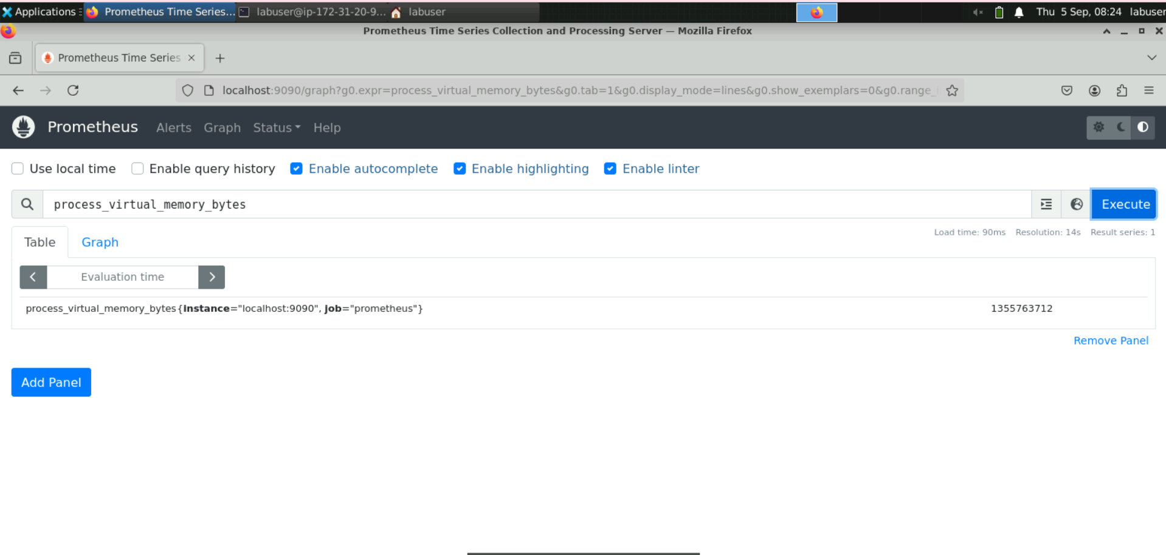

* 1. Click on the **Graph** tab to visualize **process_virtual_memory_bytes**

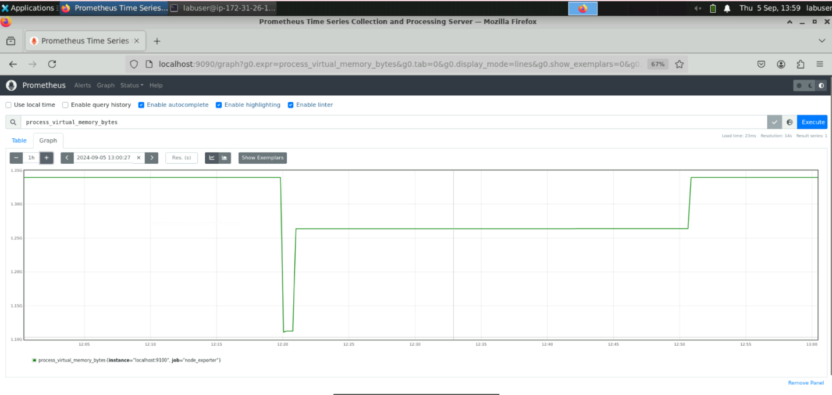

* 1. Click on the **Status** section and select **Targets**

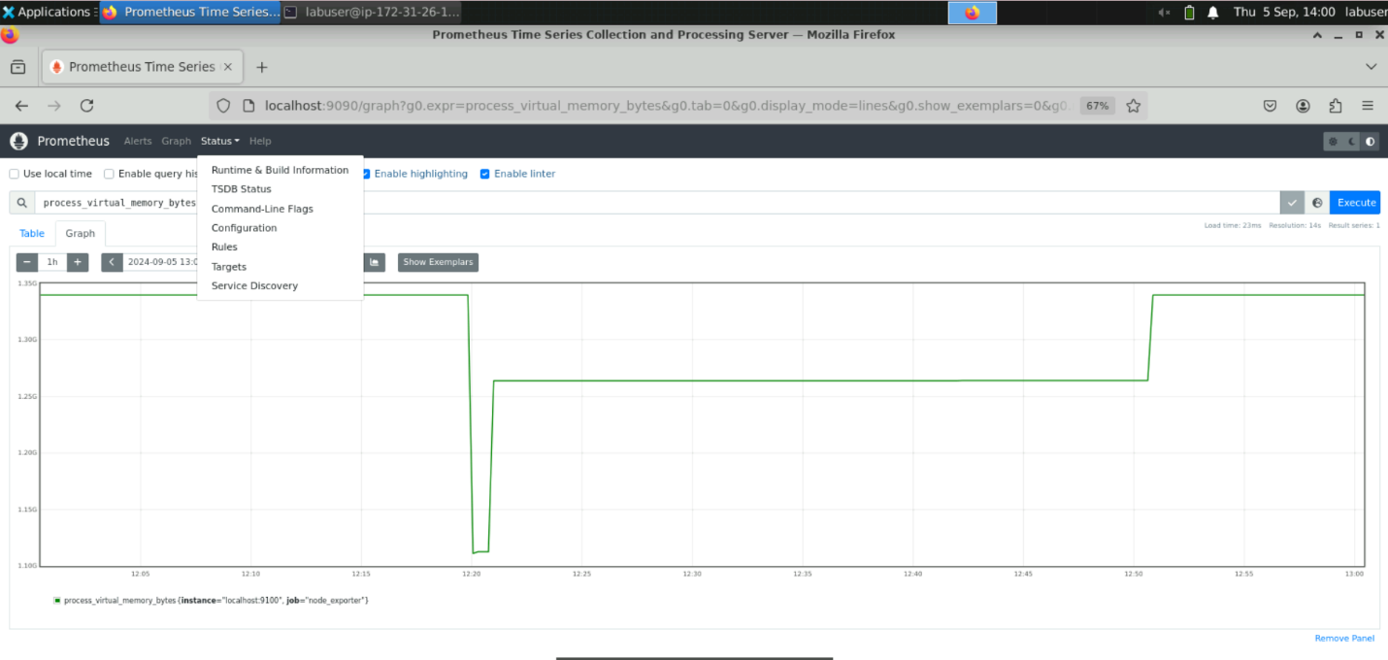

You will see the following interface:

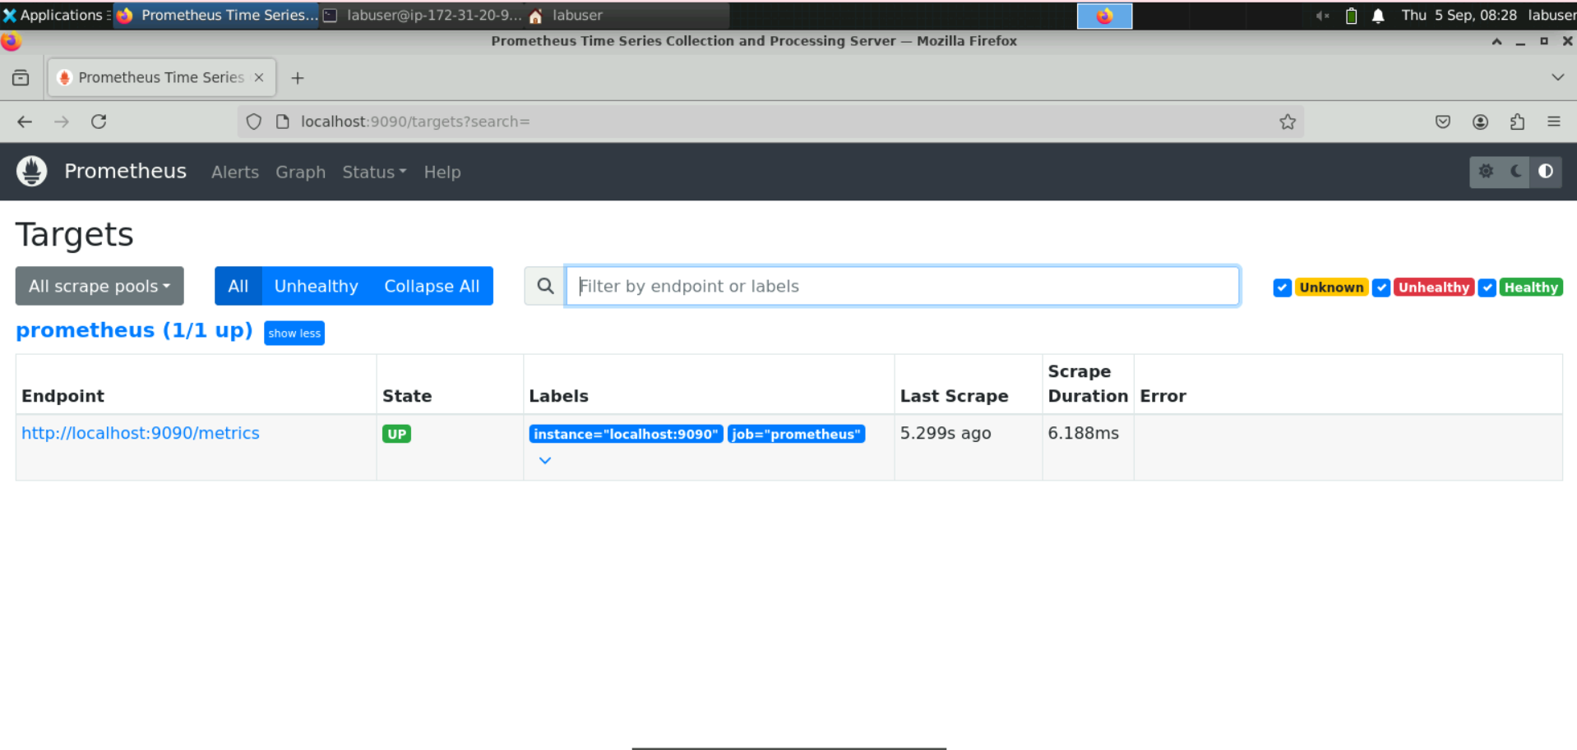

Only a single Prometheus server is in the **UP** state on this page, indicating that the last scrape was successful. If there had been an issue with the previous scrape, an error message would appear in the **Error** field.

* 1. Copy the link **http://localhost:9090/metrics** from the **Targets** page and paste it into a new browser tab as shown:

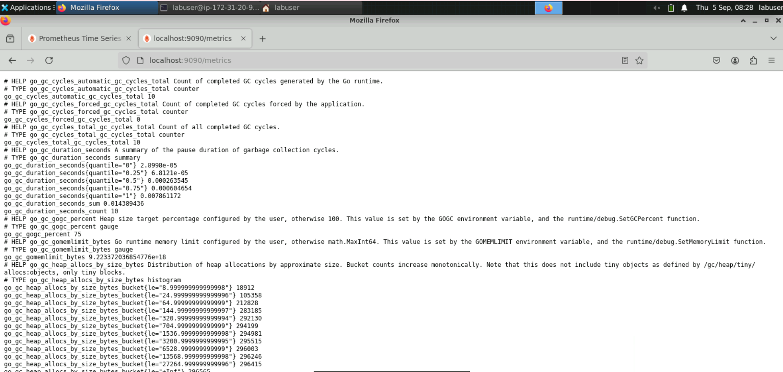  
  
This will display metrics for monitoring the application.

By following these steps, you have successfully configured Prometheus to scrape and visualize metrics for monitoring system performance through its web interface.